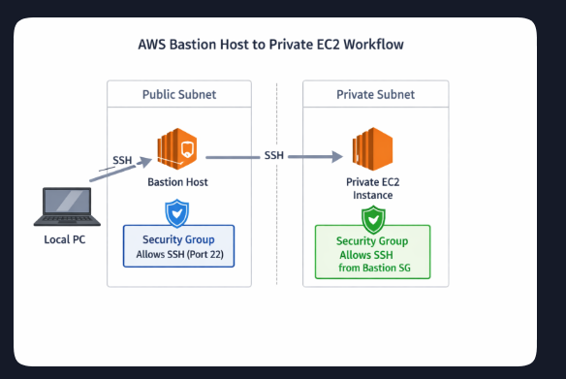
Bastion login prompt

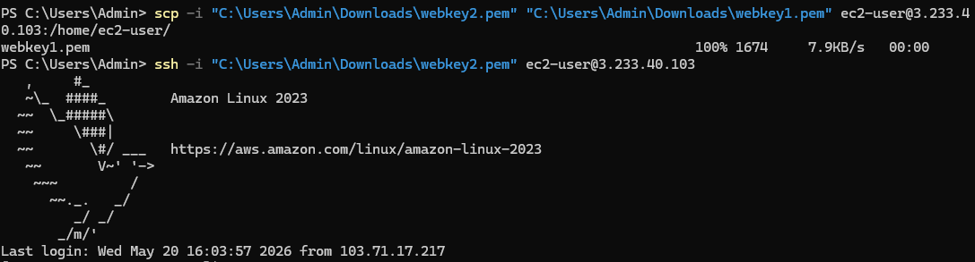

Private EC2 login prompt
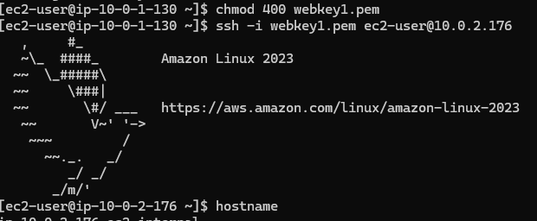

Outputs of hostname, uptime, local-ipv4, security-groups
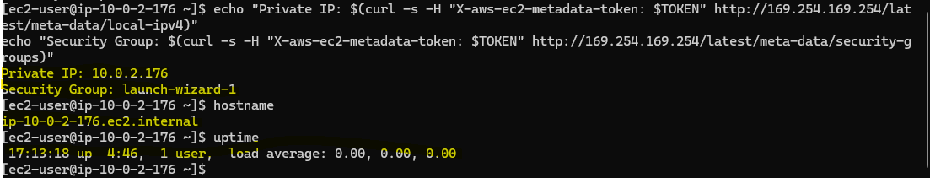

Commands
# AWS Bastion → Private EC2 Connectivity Project
# Secure VPC with Public & Private Subnets
# Commands executed during project verification

# 1. Connect to Bastion Host from Local PC
ssh -i "C:\Users\Admin\Downloads\webkey2.pem" ec2-user@3.233.40.103

# 2. Verify Bastion Host details
hostname
uptime

# 3. Set correct permissions for Private EC2 key
chmod 400 webkey1.pem

# 4. Connect from Bastion Host to Private EC2
ssh -i webkey1.pem ec2-user@10.0.2.176

# 5. Verify Private EC2 details
hostname
uptime

# 6. Generate IMDSv2 token
TOKEN=$(curl -X PUT "http://169.254.169.254/latest/api/token" \
-H "X-aws-ec2-metadata-token-ttl-seconds: 21600")

# 7. Query Private EC2 metadata
curl -H "X-aws-ec2-metadata-token: $TOKEN" \
http://169.254.169.254/latest/meta-data/local-ipv4

curl -H "X-aws-ec2-metadata-token: $TOKEN" \
http://169.254.169.254/latest/meta-data/security-groups

# 8. Optional: Display outputs neatly
echo "Private IP: $(curl -s -H "X-aws-ec2-metadata-token: $TOKEN" \
http://169.254.169.254/latest/meta-data/local-ipv4)"
echo "Security Group: $(curl -s -H "X-aws-ec2-metadata-token: $TOKEN" \
http://169.254.169.254/latest/meta-data/security-groups)"

